Batch: B2 Roll No.: 16010121200

Experiment No. 05

Grade: A / AB / BB / BC / CC / CD /DD

Signature of the Staff In-charge with date

Title: To Study and implement HEBBS learning rule

Objective: To write a program to implement HEBBS learning rule for the given data.
____________________________________________________________________________________
Expected Outcome of Experiment:
CO3: Understand perceptron’s and counter propagation networks
____________________________________________________________________________________
Books/ Journals/ Websites referred:

____________________________________________________________________________________
Pre Lab/ Prior Concepts:
Hebbian learning rule and algorithm
____________________________________________________________________________________

Flowchart:
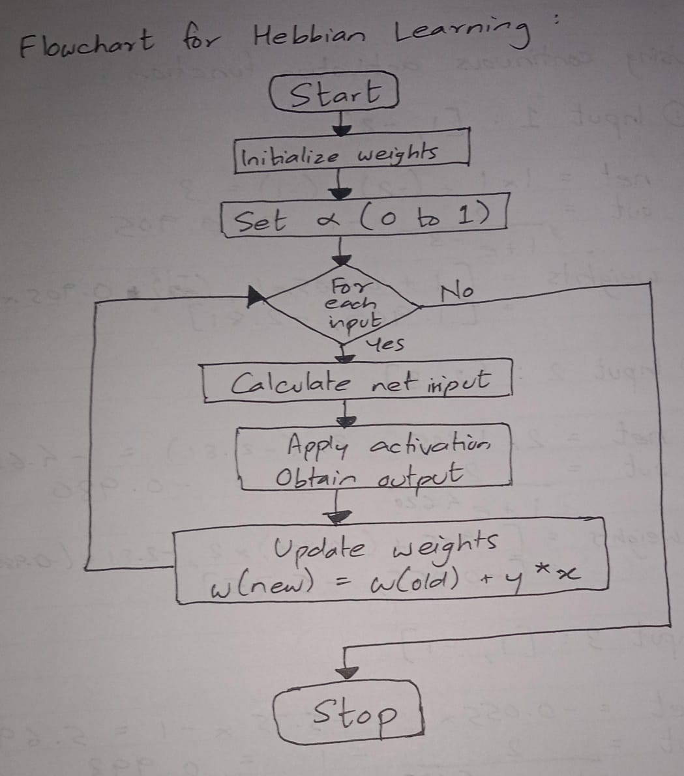

Implementation Details:
import numpy as np

# Activation function
def activation(net, mode):
if mode == 'discrete': # for discrete activation function
if net >= 0:
return 1
else:
return -1
elif mode == 'continuous': # for continuous activation function
return 2 / (1 + np.exp(-1*net)) - 1

def hebbianRule(input_vector, AF_mode):
# Initialization
lr = 1
weight = (1, -1)
w1, w2 = weight
print("\nHebbian model with", AF_mode, "activation function")
print("Learning Rate =", lr)
print("Initial weights:\nw1 = {0}\t\tw2 = {1}".format(w1, w2))

# Hebbian Learning Rule
table = []
for input in input_vector:
row = []
x1, x2 = input
net = round(x1*w1 + x2*w2, 3)
y = round(activation(net, AF_mode), 3)
w1 = round(w1 + y * x1, 3)
w2 = round(w2 + y * x2, 3)
# w3 = round(w3 + y * x3, 3)
# w4 = round(w4 + y * x4, 3)
row.extend([net, y])
row.append([w1, w2])
table.append(row)
printTable(table)
return

def printTable(table):
i = 0
print("-----------------------------------------------------------------------------")
print("net\t\t | f(net)\t\t | Updated weights")
print("-----------------------------------------------------------------------------")
for row in table:
for value in row[:-1]:
print("%5.3f" % value, end = "\t\t | ")
print(row[-1])
print("-----------------------------------------------------------------------------")

input_vector = [[1, -2], [2, 3], [1, -1]] # Create the input vector
hebbianRule(input_vector, 'discrete') # Pass the inputs to the model
hebbianRule(input_vector, 'continuous')

Output: (Initial weights and inputs were given according to the example in the post lab Q)
Hebbian model with discrete activation function:
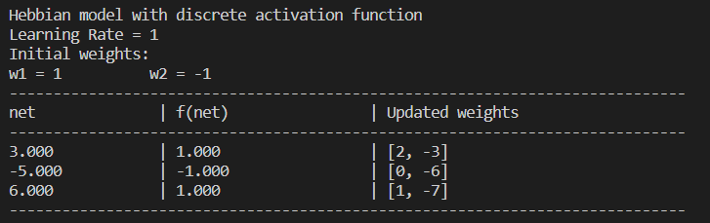
Hebbian model with continuous activation function:
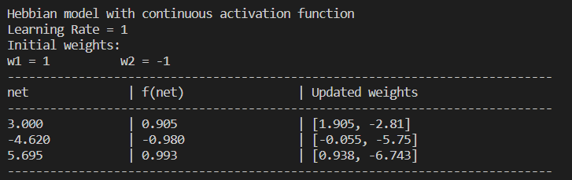
Conclusion:
Thus, we have successfully implemented Hebbian learning algorithm of Neural Network.

Post Lab Descriptive Questions:

- Compare the Hebbian learning and competitive learning.
Hebbian rule:
- Unsupervised learning.
- All weights are updated depending on the output.
- It is based on the idea that synapses between neurons are strengthened when the neurons they connect fire simultaneously.
Competitive rule:
- Unsupervised learning.
- Only the weights of the winner are updated.
- It is based on the idea of competition among neurons. Neurons compete to be the ‘winner’ by responding most strongly to particular patterns in the input data.

- Find the weights after one iteration for Hebbian learning of a single neuron network. Start with initial weights W = [1, -1] and Inputs as X1 = [1, -2], X2 = [2, 3], X3 = [1, -1] and C = 1.
  - Use bipolar binary activation function
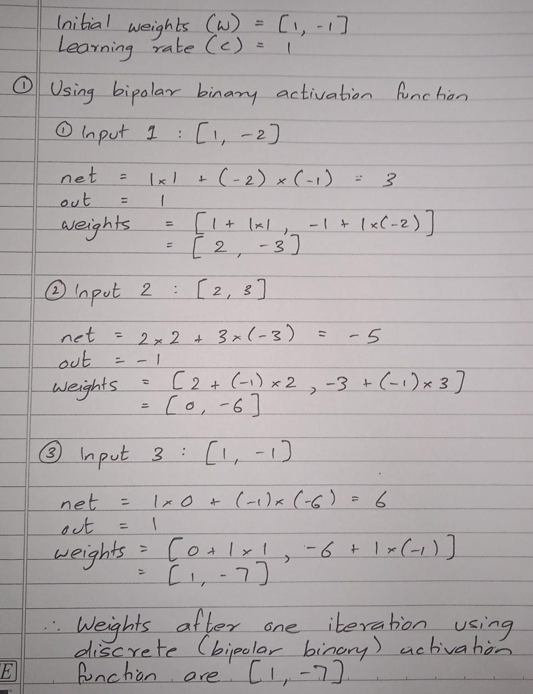

  - Use continuous activation function
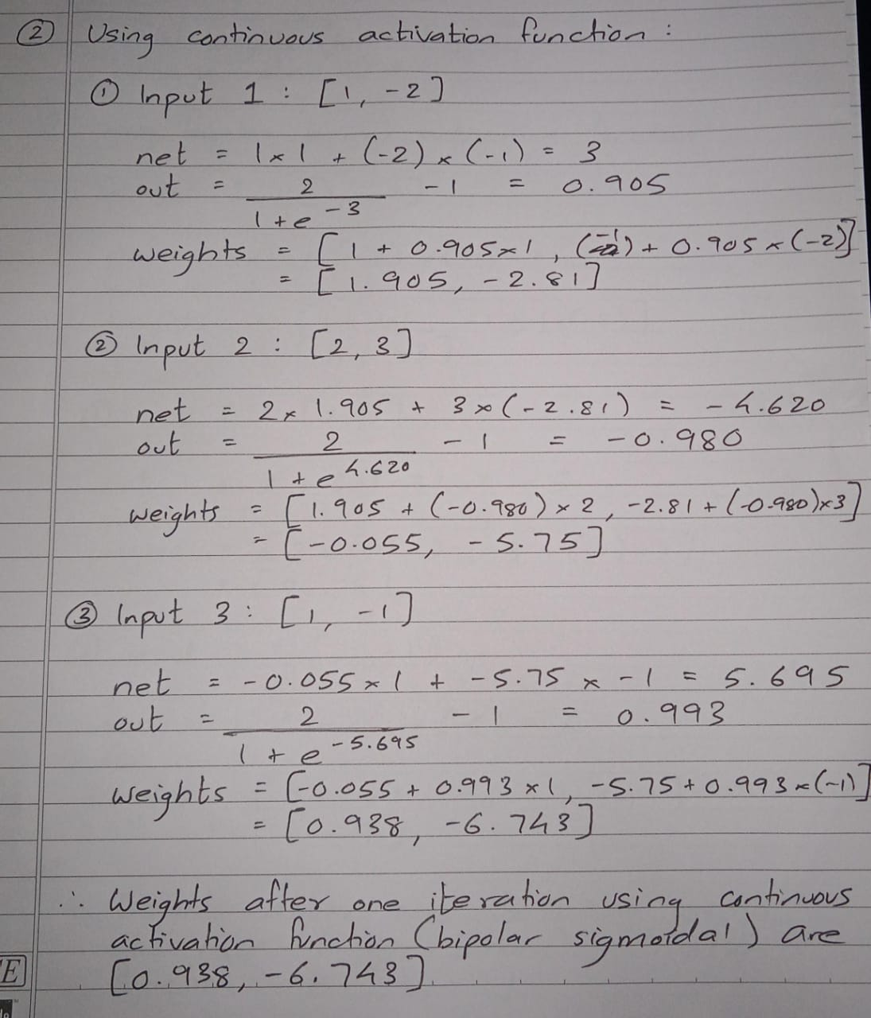

Date: 24/10/2023 Signature of faculty in-charge

